As-Is Processes
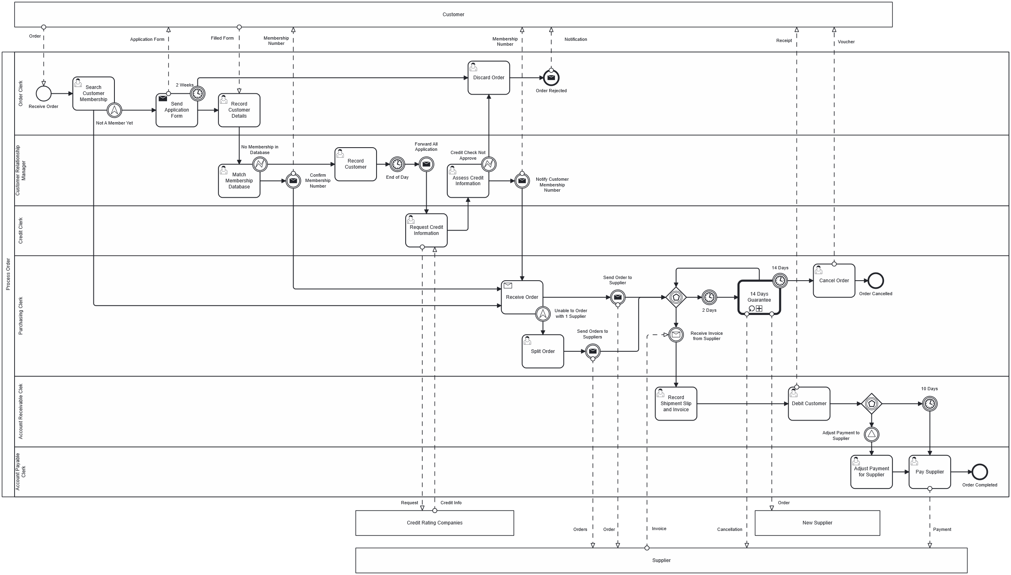
Figure 1: Process Order As-Is
Task, Gateway and Event | Explanation
Search Customer Membership | When an order is received, the Order Clerk search for customer details in the database to proceed the order.
Not A Member Yet | Handle the scenario where the customer is not a member yet.
Send Application Form | Send customer an application form to be a member.
Discard Order | Order will be discarded, and Order Clerk will send a notification to inform Customer.
Match Membership Database | Customer Relationship Manager try to match customer detail with the database to see application comes from non-member customer or lapsed member.
No Membership in Database | Handle the scenario where the customer information cannot be found in the database.
Confirm Membership Number | This means customer is lapsed member, Customer Relationship will send Customer their membership number and proceed the order.
Record Customer | This means customer is a non-member, CRM will record customer detail with no membership number.
Forward All Application | At the end of each day, Customer Relationship Manager will bundle all the applications of the day and forward them to Credit Clerk.
Request Credit Information | Credit Clerk will send request to several Credit Rating Companies for customer financial information.
Assess Credit Information | After received customer financial information, Credit Clerk will forward it to Customer Relationship Manager for assess membership application.
Credit Check Not Approve | Handle the scenario where the customer has bad credit score and cannot apply for membership.
Notify Customer Membership Number | Customer Relationship Manager send customer their membership approval.
Receive Order | Purchasing Clerk receive the order.
Unable to Order with 1 Supplier | Handle the scenario where the order cannot be order with one supplier.
Split Order | Purchasing Clerk split the order to several supplier.
Send Order to Supplier | Purchasing Clerk send the order to Supplier.
Send Order to Suppliers | Purchasing Clerk send each order to each Supplier.
Event-Based Gateway after Send Order to Supplier | Handle two scenarios (2 Days and Received Invoice from Supplier) after sending out the order to the supplier(s).
Cancel Order | Order cancelled by Purchasing Clerk due to 14-day guarantee policy.
Record Shipment Slip and Invoice | Account Receivable Clerk will record shipment slip and invoice sent by the Supplier.
Debit Customer | After record all the shipment slip and invoice for the order, Account Receivable Clerk will debit Customer credit card and send receipt to customer.
Event-Based Gateway after Debit Customer | Handle two scenarios (10 Days and Adjust Payment to Supplier) after debit customer.
Adjust Payment for Supplier | After signal event Adjust Payment to Supplier is triggered, the Account Payable Clerk adjust the payment to Supplier.
Pay Supplier | The Account Payable Clerk pay supplier(s) for the wine delivered to Customer.

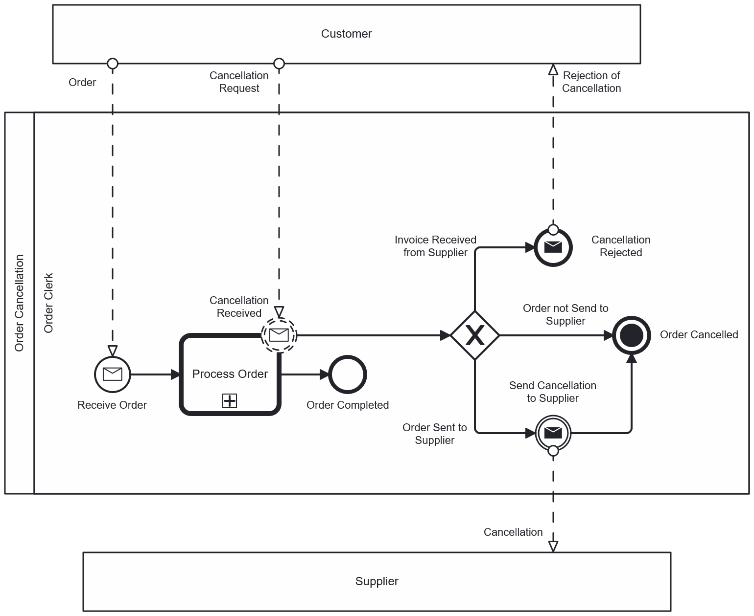
Figure 2: Order Cancellation As-Is
Task, Gateway and Event | Explanation
Cancellation Received | Handle the scenario where the send cancellation request while the order being process.
Exclusive Gateway after Cancellation Received | Handle three scenarios (Invoice Received from Supplier, Order not Send to Supplier, Order Sent to Supplier) after cancellation request received.
Cancellation Rejected | If invoice already received from supplier, cancellation will be rejected and a notification and will be sent to customer.
Order Cancelled | If the order has not sent to supplier, the order will be cancelled
Send Cancellation to Supplier | If the order has sent to supplier and invoice not yet received, a cancellation will be sent to supplier(s).

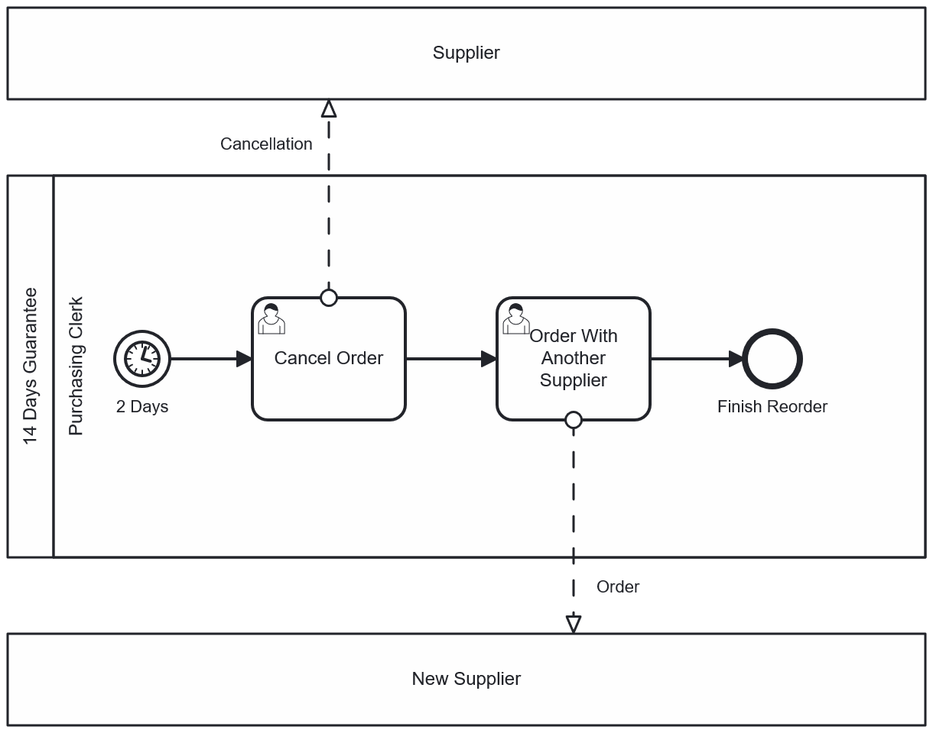
Figure 3: 14 Days Guarantee As-Is
Task, Gateway and Event | Explanation
Cancel Order | Purchasing Clerk cancel order with current Supplier.
Order With Another Supplier | Purchasing Clerk try to order with another Supplier.

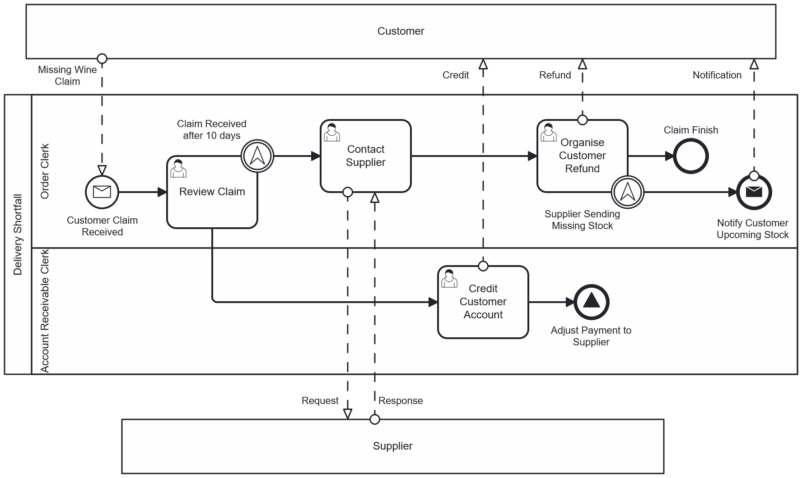
Figure 4: Delivery Shortfall As-Is

Task, Gateway and Event | Explanation
Review Claim | After the claim is received, Order Clerk will review the claim to see if the payment sent to supplier(s) yet.
Claim Received after 10 days | Handle the scenario where the claim received 10 days after the day customer debit for the order.
Credit Customer Account | Account Receivable Clerk institute a credit to Customer’s account.
Adjust Payment to Supplier | Signal end event that triggers the event in the Process Order model.
Contact Supplier | Order Clerk contact supplier to resolve the problem by letting them choose between recoup or reorganise sending missing stock.
Organise Customer Refund | Order Clerk organise a refund for Customer.
Supplier Sending Missing Stock | Handle the scenario where the supplier chooses to reorganise sending missing stock.
Notify Customer Upcoming Stock | Order Clerk send notification to Customer for the delivery of missing stock.

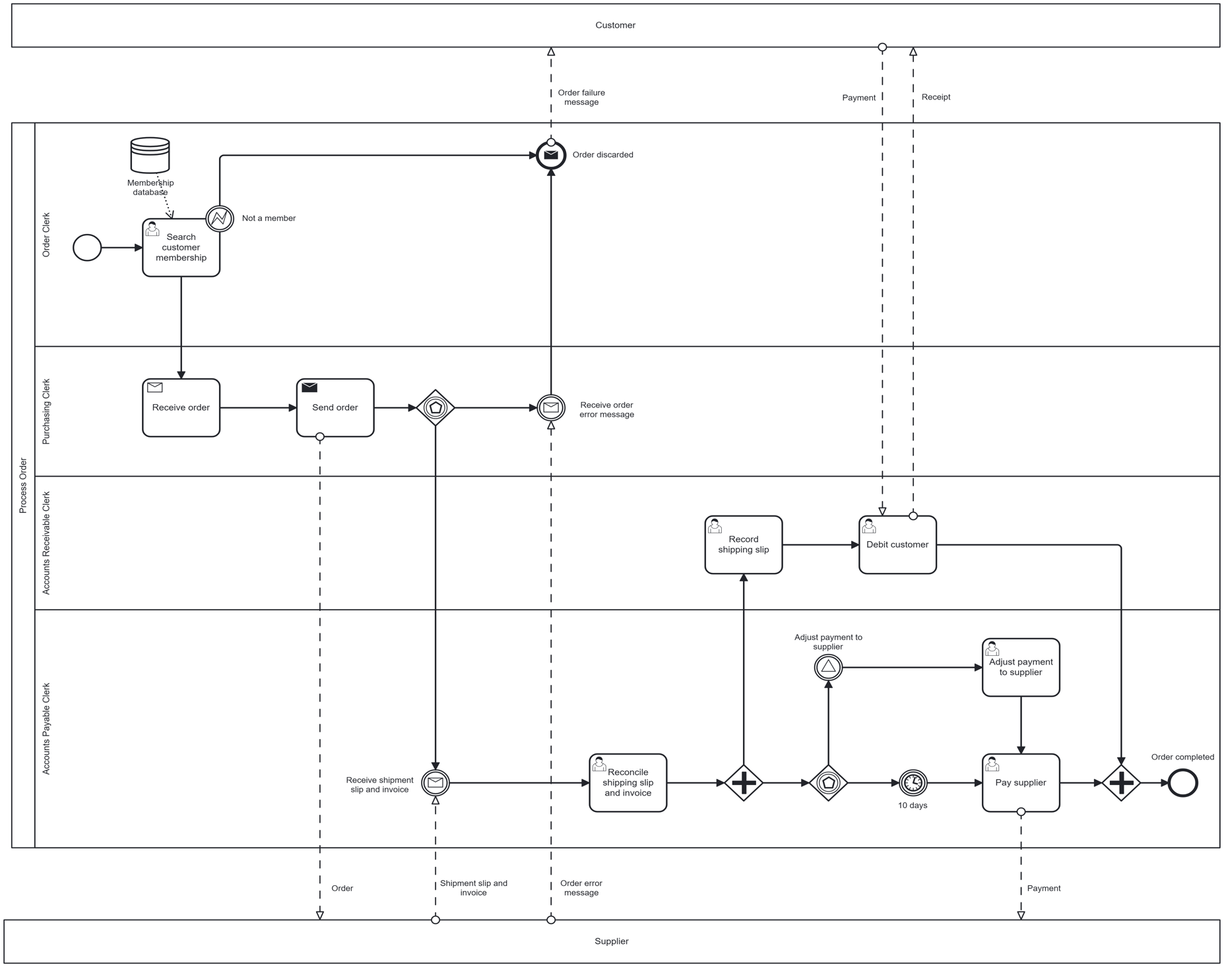
To-Be Processes
Figure 5: Process Order To-Be

Task, Gateway and Event | Explanation
Search Customer Membership | Order clerk attempts to match the customer’s membership with corresponding information in the membership database. The interrupting error boundary event would divert non-members to have their order be discarded.
Receive Order | The order is received by the purchasing clerk, sent by the order clerk.
Send Order | The purchasing clerk forwards the order to the appropriate supplier
Event Gateway – After Send Order | Message catch event triggered by receiving order error message from supplier and then cancelling the order; message catch event triggered by receiving shipping slip and invoice from supplier and moving to reconciling the documents.
Receive Order Error Message | The supplier sends an error message regarding the order, received by the purchasing clerk, who then discards and cancels the order.
Reconcile Shipping Slip and Invoice | Accounts payable clerk receives shipping slip and invoice from supplier and reconciles it with the original customer order.
Event-Based Gateway after Debit Customer | Handle two scenarios (10 Days and Adjust Payment to Supplier) after debit customer.
Record Shipping Slip | Accounts receivable clerk receives the shipping slip from the accounts payable clerk and records the details.
Debit Customer | Accounts receivable clerk debits the customer and sends a receipt.
Adjust Payment to Supplier | A signal is received from the delivery shortfall process, and accounts payable clerk adjusts the payment amount to the supplier.
Pay Supplier | Supplier is paid by accounts payable clerk.

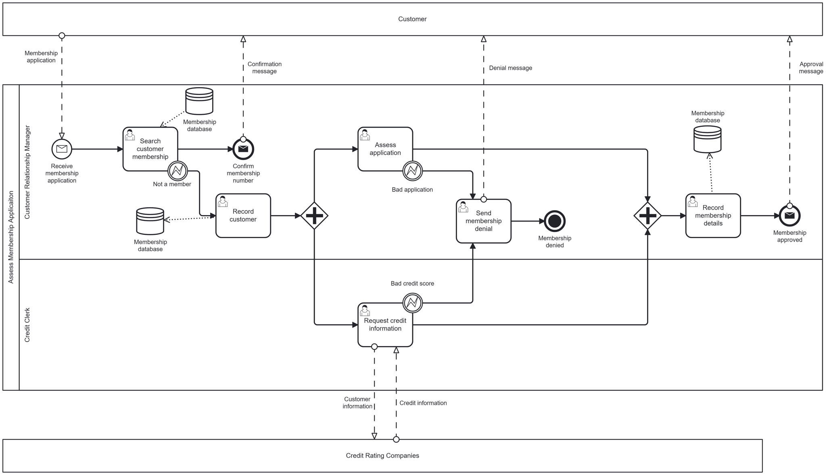
Figure 6: Assess Membership Application To-Be

Task, Gateway and Event | Explanation
Match Membership Database | Customer relationship manager matches application details with preexisting entries in membership database, sending a confirmation message to the customer if found. Interrupting boundary error event triggers if a match is not found.
Record Customer | Customer’s application details are recorded in the membership database by customer relationship manager.
Assess Application | Application details are assessed by customer relationship manager to see if they are valid. Interrupting boundary error event triggers if the application is invalid, moving process to send membership denial.
Request Credit Information | Credit clerk requests credit information from credit rating companies. Interrupting boundary error event triggers if the received credit score is below a certain threshold, moving process to send membership denial.
Send Membership Denial | Customer relationship manger cancels the application and sends a denial message to the customer, terminating the process.
Record Membership Details | Customer Relationship Manager records membership details, including membership number in the membership database, and sends an approval message to the customer to end the process.

Automated Processes
Business Case | Assumption
Website | The website always asks customer to fill in the application before placing any orders from the business. Whenever the application is submitted, it sends straight away to the BPMS to process its information.
Automated Membership Approval process | This process always occurs before placing any order from the customer. As mentioned in the recommendation part, it might take more time but when the membership is approved, it will process the order straight away instead of the 14-day-period to only generating the membership number. As the service offering the website is a pay-as-you-go concept which mean it is financial efficiency.

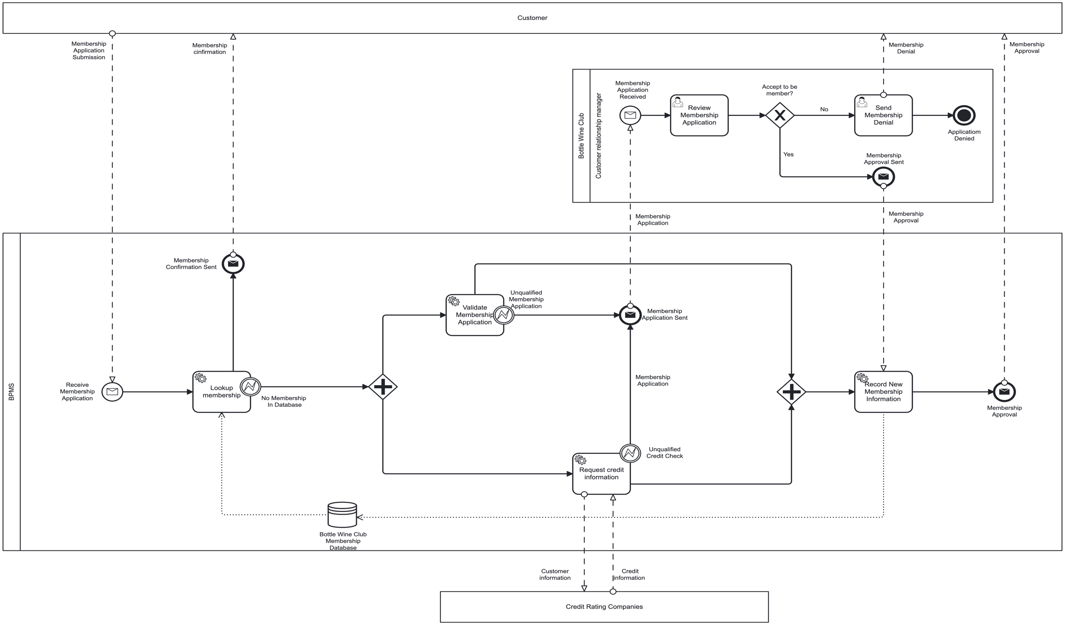
Figure 7: Automated Membeship Approval
Task, Gateway and Event | Explanation
Membership Application Received | When the application is received via the website, triggering the initialization of the process.
Lookup Membership | The BPMS looks up the customer in the membership Database. If:  - The customer has already been a member, send them the membership confirmation to acknowledge them their ability to place an order.  - If the customer’s information is not found in the database, process them to the next step to verify their information before placing an order.
Validate Membership Application | Validating the membership application, if:  - The validation is qualified, process them to the next steps.  - The validation is unqualified, forward the application to Customer Relationship Manager to consider.
Request Credit Information | Checking customer’s credit history with external character (Credit Rating Companies) to make sure the customer has the ability to make payment for their purchase, if:  - Credit Check is qualified, process them to the next step.  - Credit Check is unqualified (it could be bad credit check or invalid customer information), forward the application to Customer Relationship Manager to consider.
Review Membership Application | Customer Relationship Manager review the application to consider whether the application can continue to be process as business needs customer so it will be necessary to have this user step in the process to make use of every potential application.
Accept to be member? | If the application is:  - Approved, send membership approval message to BPMS to continue the process  - Declined, process to the next step of declining to be a member
Send Membership Denial | Send membership denial to acknowledge customer that their application is not qualified to be a member with the business.
Record New Membership Information | BPMS save the customer information to the membership database for future purchase.

